

STATE OF INDIANA

Request for Proposal 20-041

Addendum #2

INDIANA DEPARTMENT OF ADMINISTRATION

On Behalf Of
Family and Social Services Administration
Office of Medicaid Policy and Planning

Solicitation For:
Risk-Based Managed Care Services for Aged, Blind and Disabled Medicaid Beneficiaries
(Hoosier Care Connect)

Response Due Date: January 6th, 2020

David Brandon-Friedman
Indiana Department of Administration
Procurement Division
402 W. Washington St., Room W468
Indianapolis, Indiana 46204
Summary of Changes
Deletions are indicated via strikethrough and additions are underlined, both in red font.

- The following edits have been made to Attachment F, Technical Proposal Instructions:

- In Submission Specifications:
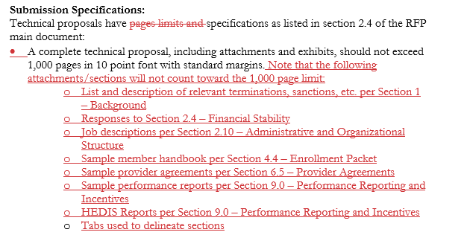

- In Section 1.0 – Background:
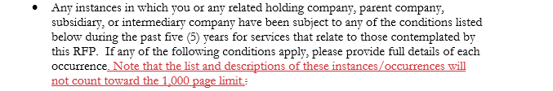
- In Section 2.0 – Administrative Requirements, Section 2.4 – Financial Stability:

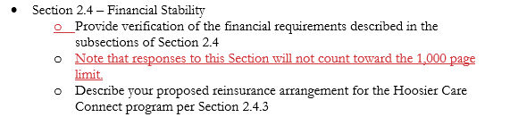

- In Section 2.0 – Administrative Requirements, Section 2.10 – Administrative and Organizational Structure:
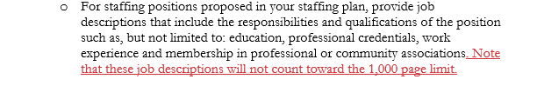
- In Section 4.0 – Member Services, Section 4.4 – Enrollment Packet:
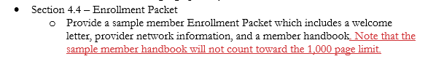
- In Section 6.0 – Provider Network Requirements, Section 6.5 – Provider Agreements:
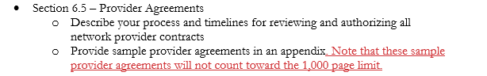
- In Section 9.0 – Performance Reporting and Incentives:
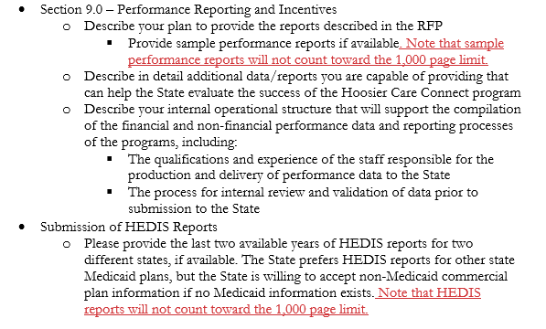

- In Section 9.0 – Performance Reporting and Incentives, Submission of HEDIS Reports:

- The following edits have been made to Attachment I, Exhibit 1 Scope of Work:

- In Section 7.3.1 Authorization of Services and Notices of Actions:
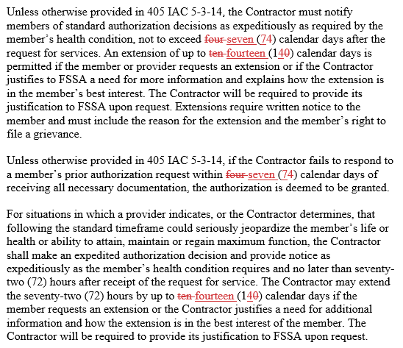

- The following edits have been made to Attachment K, Exhibit 3 Program Description and Covered Benefits:

- In the Smoking Cessation and Tobacco Dependence Treatment Services row of Table 1: Hoosier Care Connect Benefits:

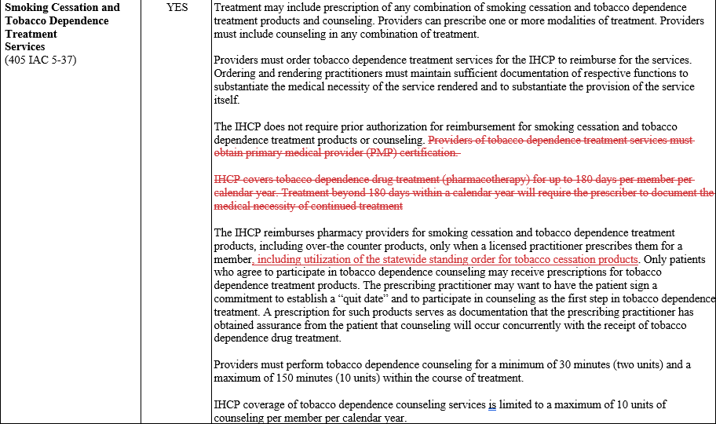

- The following edits have been made to Attachment M, Exhibit 5 Capitation Rates:

- In Note on Incentive Payment Withholding:
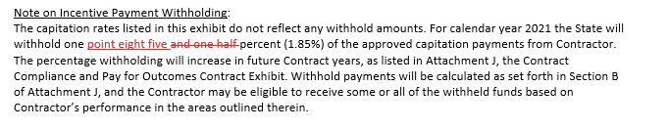
- The following edits have been made to Attachment O, Capitation Rate Data Book:

- In Section I.4.iii.(c) Reinsurance Requirements and Effect on Capitation Rates:

